URL: [Click-Here](https://chewyuhan.github.io/FIT3179-Asm2/Week_10_Homework/)

Screenshot:

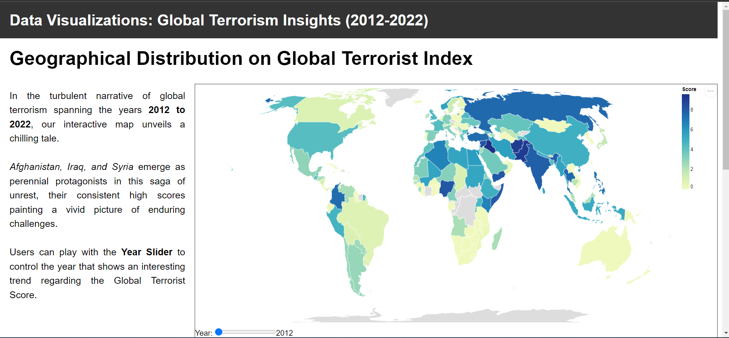

* Domain of the visualisation:
  + There are two domains used in this dashboard: Global Terrorist Index (which shows the overall geographic and terrorist index) and Global Terrorist (which shows the terrorist attack by year).
  + The domain of the visualisation is the "Global Terrorism Index (GTI)," which assesses the impact of terrorism in 163 countries from 2012 to 2022, covering 99.7% of the world's population. It aims to understand how the impact of terrorism varies across countries and over time.
* Visualised Dataset:
  + Attributes: The dataset used in the visualisation includes the following attributes:
    - "Country": The name of the countries.
    - "Year": The year for which the Global Terrorism Index (GTI) data is being visualised.
    - "Score": The GTI score, representing the impact of terrorism on a scale from 0 to 10.
    - “Terrorist Attack”: The terrorist attack shows the number of terrorist attacks for each country each year.
  + Source and Author:
    - The “Global Terrorism Index” is from the Institute for Economics and Peace (IEP). The authorship of the data belongs to IEP.
    - The “Global Terrorist” authorship is from Mexwell (2023).
  + Data Transformation:
    - The dataset given is clean and tidy. I just removed some unused data, such as ISO 3C code. Normalisation is not needed because the data itself represents the score for a specific year, and the data originally had been normalised into a range of 0–10.
    - I also filter out the year, focusing only on 2012–2022.
  + Justification for the Choropleth Map:
    - A choropleth map is chosen to visualise GTI scores across countries, effectively using colours to show variations in terrorism impact.
    - A slider allows users to explore how GTI scores change over time, aiding trend analysis.
    - A proportional symbol map typically represents data using different-sized symbols, which might not be as suitable for visualising the distribution of a single continuous variable like the GTI score across countries.
    - Dot maps are often used for displaying point data, which may not be appropriate for country-level data unless you are plotting specific incidents.
  + Bubble Plot
    - A bubble plot is chosen to visualise the number of terrorist attacks by year, effectively using colour to show variations of region across the world.
    - A slider to control the number of terrorist attacks, letting users show what range of data they want.
    - Region selection is used to select a region, allowing the user to select the region they want.
    - A stacked bar chart or line chart is not suitable for this visualisation due to the high volume of countries in the data.

Reference List

dee, dee. (2023). Global Terrorism Index 2023. Retrieved October 6, 2023, from Kaggle.com website: <https://www.kaggle.com/datasets/ddosad/global-terrorism-index-2023>

‌mexwell. (2023). 💣 Global Terrorism. Retrieved October 6, 2023, from Kaggle.com website: <https://www.kaggle.com/datasets/mexwell/global-terrorism>

‌